- Tên và phân loại:

- Mục đích, ý nghĩa:
- Define an interface for creating an object, but let subclasses
decide which class to instantiate
- Factory Method lets a class defer instantiation to subclasses
- Động lực sử dụng:
- Consider a framework for a multi-document application
- CreateDocument() is factory method
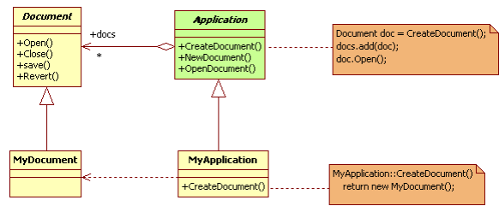
- Khi nào sử dụng:
- A class can't anticipate the class of objects it must create
- A class wants its subclasses to specify the objects it creates
- Classes delegate responsibility to one of several helper
subclasses, and you want to localize the knowledge of which
helper subclass is the delegate
- Cấu trúc
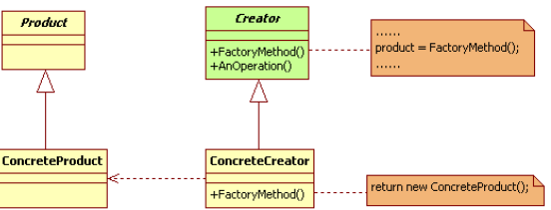
- Các thành viên - Sự cộng tác
- Product: defines the interface of objects the factory method creates
- ConcreteProduct: implements the Product interface
- Creator
• Declares the factory method, which returns an object of type Product
• May also define a default implementation of the factory method that
returns a default ConcreteProduct object
• May call the factory method to create a Product object
- ConcreteCreator: overrides the factory method to return an instance
of a ConcreteProduct
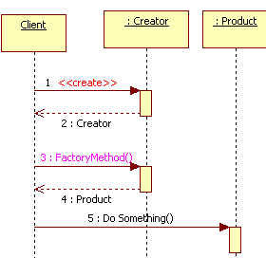
- Các hệ quả mang lại:
- Provides hooks for subclasses
• Creating objects inside a class with a factory method is always
more flexible than creating an object directly
• Gives subclasses a hook for providing an extended version of an
object
- Connects parallel class hierarchies
• In the examples we've considered so far, the factory method is
only called by Creators. But this doesn't have to be the case;
clients can find factory methods useful, especially in the case of
parallel class hierarchies
- Chú ý liên quan đến cài đặt:

- Hệ thống thực tế

- Mẫu liên quan
- Abstract Factory is often implemented with Factory Methods
- Factory Methods are usually called within Template Methods
- Prototypes don't require sub-classing Creator

